OTA Upgrade to Pegasus Star
Copy the OTA files c\centrak\firmware folder

In Local streaming client tool Goto command options in the left bottom corner

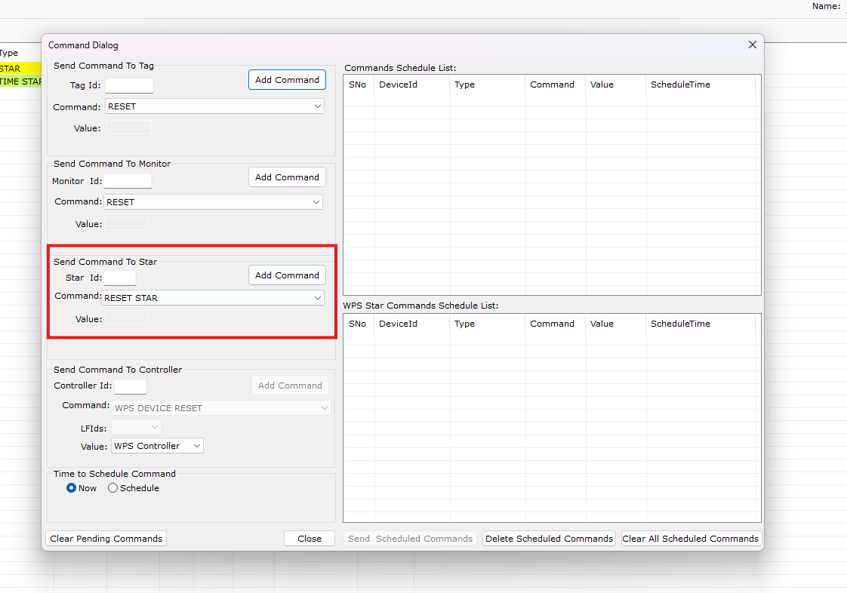

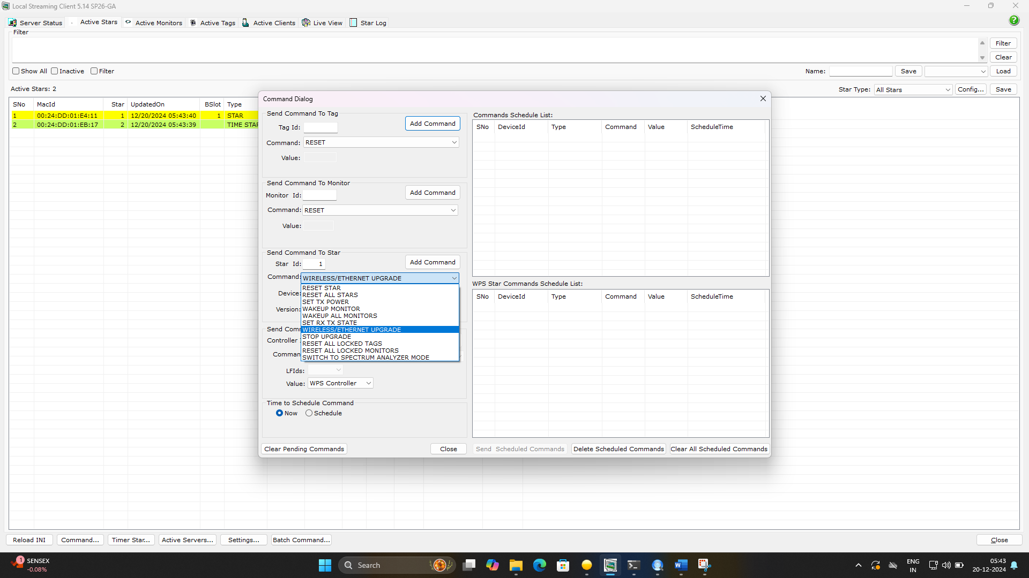

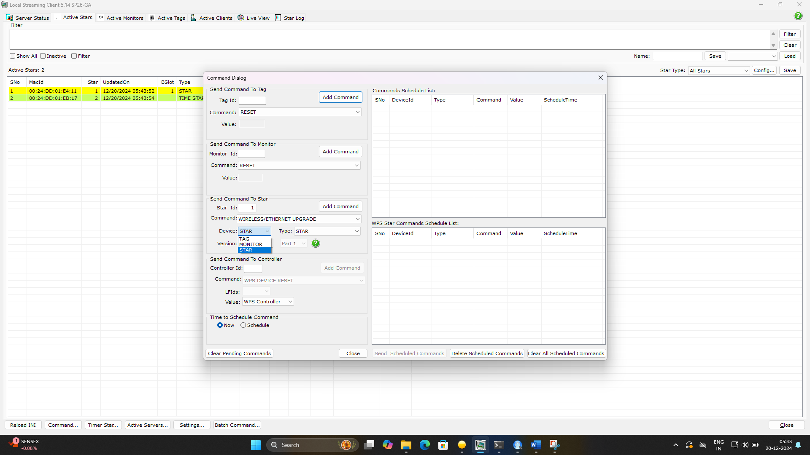
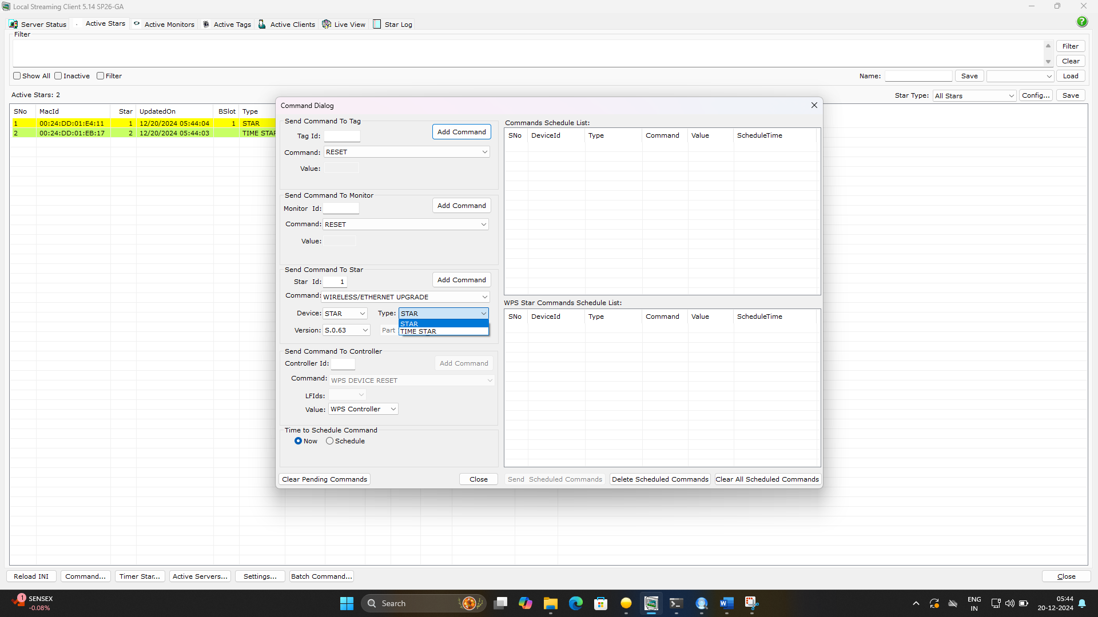
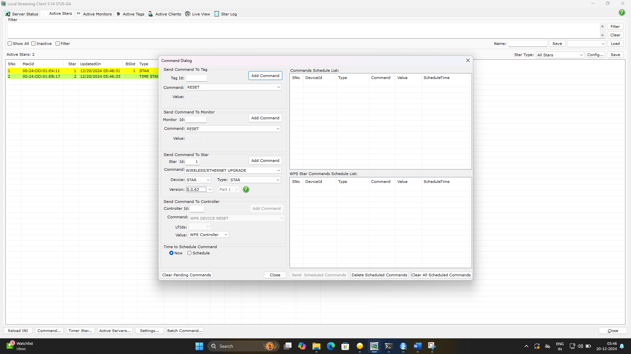
Click in addCommand
Upgrade will start and displays upgrader in Star row and color changes to blue
